HD 220689

HD 220689 is a 1.04 M☉, G3 V star1. Based on 44 RV CORALIE measurements obtained between 2000 and 2012, a study performed in 2013 (hereafter M13)1 reported a GP signal with a period of days, a minimum mass of 1.06 ± 0.09 MJup and an eccentricity of . The CH survey reported a GP signal with properties close to those reported in the M13 study.

In the present study, in addition to the M13’s dataset[1], 43 RV HARPS measurements obtained between 2014 and 2019 were used. DPASS and MCMC (1000 walkers and 400000 iterations) were used to fit the data. The properties of HD 220689b are close to those reported in the CH survey.

The fits are shown in Fig 1, and the corner plot in Fig 2, and the results summarized in Table 1.

Conclusion: The properties found in the CH survey for HD 220689b are confirmed.

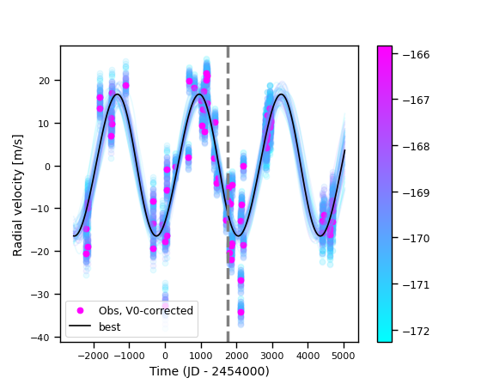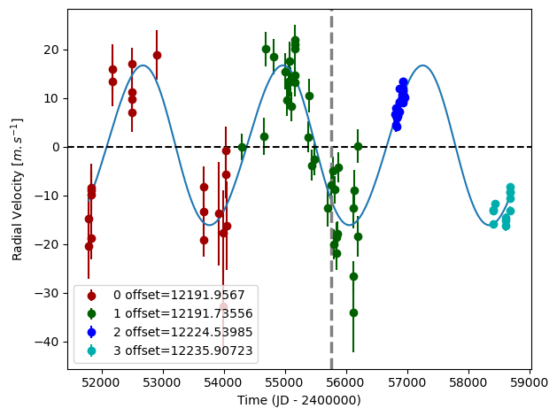

Figure 1: Left: fit of the HD 220689 RV with DPASS. Red - C98, green - C07, blue - H03, cyan - H15. The blue curve shows the best fit. Right: fit of the HD 220689 RV using MCMC. The black curve shows the best fit. The colorbar corresponds to the log-likelihood of the fits. The gray dotted line indicates the end of the CH survey.

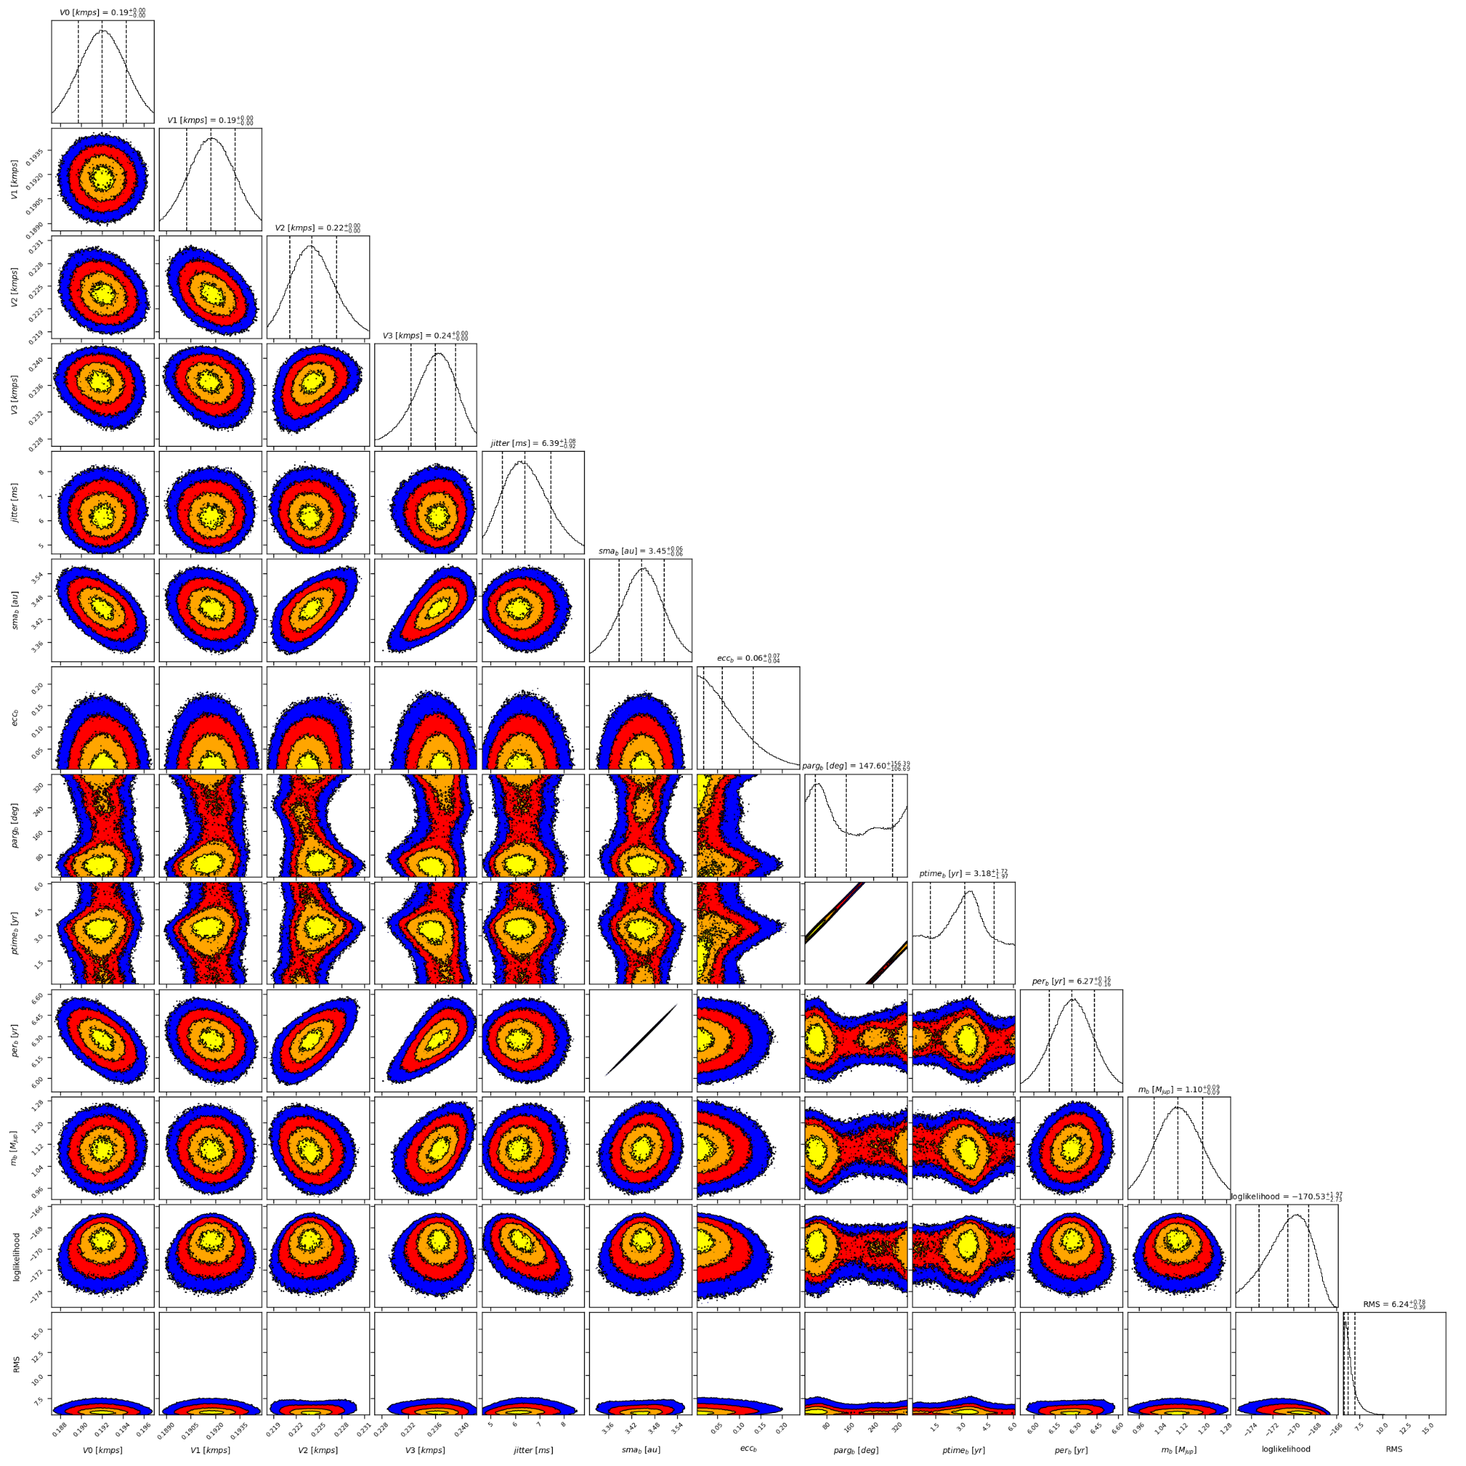

Figure 2: Corner plot of posteriors for the one-planet model MCMC fit of HD 220689 RV data.

| Parameter | Priors | | Posteriors | | CH survey |
| --- | --- | --- | --- | --- | --- |
|  | DPASS | MCMC | DPASS | MCMC |  |
| *a* (au) | [2,80] | [1,5] | 3.46 | 3.45 ± 0.06 | 3.3 |
| Msin(i) (MJup) | [0,100] | [0.5,10] | 1.08 | 1.10 ± 0.09 | 1.2 |
| Eccentricity | [0,0.95] | [0.01,0.5] | 0.07 | < 0.13 | 0.2 |
| Instrumentals offsets (km/s) | [-60,60] | [-13,-11] | C98: 12.192  C07: 12.192  H03: 12.225  H15: 12.236 | C98: 12.192±0.002  Hir94: 12.192±0.002  Hir04: 12.224 ± 0.003  H03: 12.236+0.003-0.004 |  |
| Stellar jitter (m/s) | [0,40] | [0,100] | 5.4 |  |  |
| Argument of periastron (°) | [0,360] | [0,360] | 36.7 | 41 – 304 |  |
| Phase | [0,1] | [0,1] | 0.95 | 0.19 – 0.79 |  |

Table 1: HD 220689. Summary of priors and posteriors obtained with DPASS and MCMC, compared to the properties reported by the CH Survey.

References

1. Marmier, M. et al. The CORALIE survey for southern extrasolar planets XVII. New and updated long period and massive planets. *Astron. Astrophys*. 551, A90 (2013).

1. The CORALIE data used were not available on the CDS database; therefore these data were recovered from DACE but they are not exactly the same as those used by M13 study1 (56 RV CORALIE data available in DACE against 44 RV CORALIE data for Marmier’s dataset). Yet, the RV curve obtained for the CORALIE dataset was the same.